Name: Archit Vishnoi

GitHub Username: v-archit

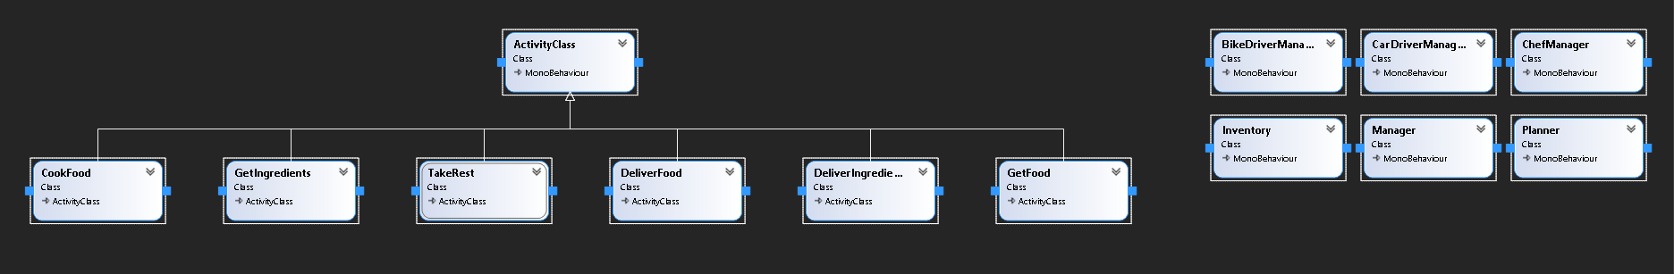Repository Name: GOAP-AI

Reason: I chose GOAP to implement the AI architecture due to its versatile nature and high performance in dynamic environment.

AI Design:

A scenario is taken of a food joint where a food order is placed, and the food is delivered to the delivery location using GOAP AI.

Agents:

1. Chef: Prepares food in kitchen by using ingredients. Goes to take rest if stored food quantity is greater than 10. 1 ingredient unit converts to 2 food units.
2. Bike Driver: Brings ingredients from Store to the Kitchen. Stays idle till the stored ingredients are less than 15. Bike Driver can carry only 4 ingredient units at a time.
3. Car Driver: Delivers food by picking food from kitchen and going to the delivery place. Car driver can carry only 3 food units at a time.

States:

state.Add("hasIngredients", (ingredients >= 2));

state.Add("hasFood", (cookedFood >= 2));

state.Add("hasFoodForDelivery", (foodForDelivery >= 3));

state.Add("hasIngredientsForDelivery", (ingredientForDelivery >= 4));

state.Add("hasFoodDelivered", !isFoodOrdered);

state.Add("hasIngredientsDelivered", (ingredients >= 15));

state.Add("hasIngredientsInStore", true);

state.Add("takeRest", !(cookedFood >= 10));